Ross Walendziak Econometrics, Assignment 5 5/18/2021

Introduction and Statement of Purpose:

National rankings seem to have greater and greater importance in distinguishing academic institutions from one another. Newly published university rankings often receive coverage from national media outlets. Prospective students often seek out national rankings to determine the level of competency at a university without fully understanding the inputs to a university ranking structure. This short report seeks to determine if university faculty characteristics influence university ranking. Specifically, does faculty pay have a causal effect on university ranking when controlling for other faculty characteristics?

Although there were several student-oriented variables in the data set that could prove helpful in explaining academic ranking, such as student SAT score or student acceptance rate—it is this author’s opinion that those variables are response functions rather than causal factors of academic ranking. In other words, strong students with strong SAT scores apply to strong academic institutions not principally because of low acceptance rates, but because strong universities have the resources that allow students to learn from expert faculty and benefit from a strong academic infrastructure, in many forms.

Data:

|  |  |  |  |  |  |  |  |  |
| --- | --- | --- | --- | --- | --- | --- | --- | --- |
| Academic Ranking & Faculty Attributes | | | | | | | | |
|  | **mean** | **std** | **skew** | **min** | **25%** | **50%** | **75%** | **max** |
| Rescaled Academic Ranking | 53.19 | 27.83 | 0.05 | 3 | 29 | 52.5 | 76 | 100 |
| Average Professor Salary | 137,104.16 | 25,784.60 | 0.72 | 85,824.00 | 118,692.00 | 131,251.50 | 154,012.50 | 202,464.00 |
| Student Faculty Ratio | 15.24 | 5.03 | -0.18 | 5 | 11 | 16 | 19 | 27 |
| Percent Economics Faculty | 2.14 | 1.30 | 2.52 | 0.61 | 1.30 | 1.83 | 2.65 | 9.50 |
| Percent Female Faculty | 39.27 | 4.45 | -0.20 | 25.45 | 36.77 | 39.44 | 41.71 | 50.96 |
| * Data represents 98 top universities from the year 2015 | | | | | | | | |

The dependent variable (‘Y’ variable) in this report is a rescaled ranking of academic proficiency. The original ranking, as published by the National Center for Education Statistics (NCES), was rescaled in this report so that higher rankings are associated with larger numbers. For example, an original score of 1 corresponds to a rescaled score of 100, 2 to 99, 3 to 98—and so on. This rescaled ranking will yield intuitive benefits when interpreting regression coefficients later in the report. The primary explanatory variable is average professor salary in annual dollars per year. Average faculty pay serves as proxy for quality of the faculty at an institution. The control variables are student to faculty ratio; percent economics faculty, representing share of economics department faculty relative to all faculty at a university; and percent female faculty, representing the percent of faculty at a university who are female. The student to faculty ratio can be thought of as a measure of the amount of faculty hired relative to the size of an institution. A higher ratio represents lower amounts of faculty relative to students enrolled at a university. Percent economics faculty can be thought of as a proxy to estimate the strength of a university’s ties to the larger economic and business communities. Percent female faculty can be thought of as a measure of diversity with an institution’s faculty positions. Percent control variables are in whole number format.

The academic ranking variable is approximately centered around its mean of 53.19, with skew close to zero. Rankings range from a minimum of 3 to a maximum of 100. Standard deviation of academic ranking is about 28 points. Average professor salary is skewed to the right, with average salary at approximately $137,000 per year and maximum salary at approximately $202,500 per year. Student to faculty ratio has a wide range, with standard deviation of 5 and minimum and maximum values of 5 and 27, respectively. There is relatively little variability of percent economics faculty, with an inner quartile range of only 0.82 percent. Percent female faculty has an average value of 39 percent, with the distribution sked mildly to the left.

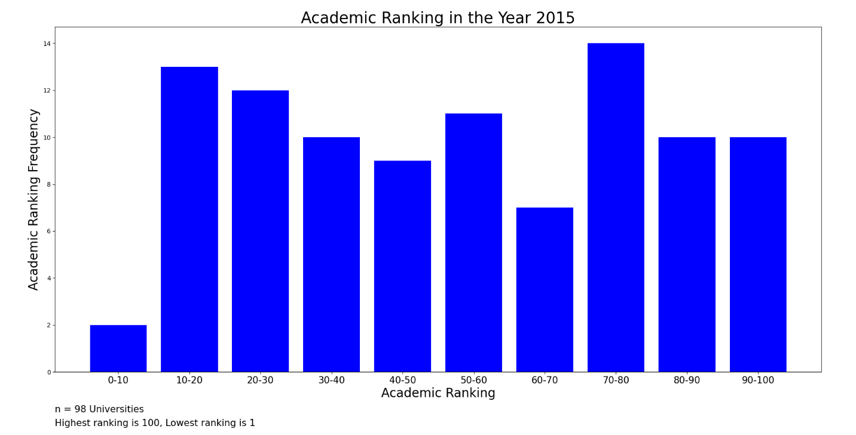 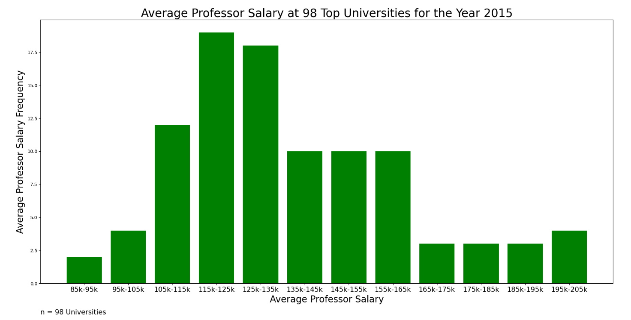

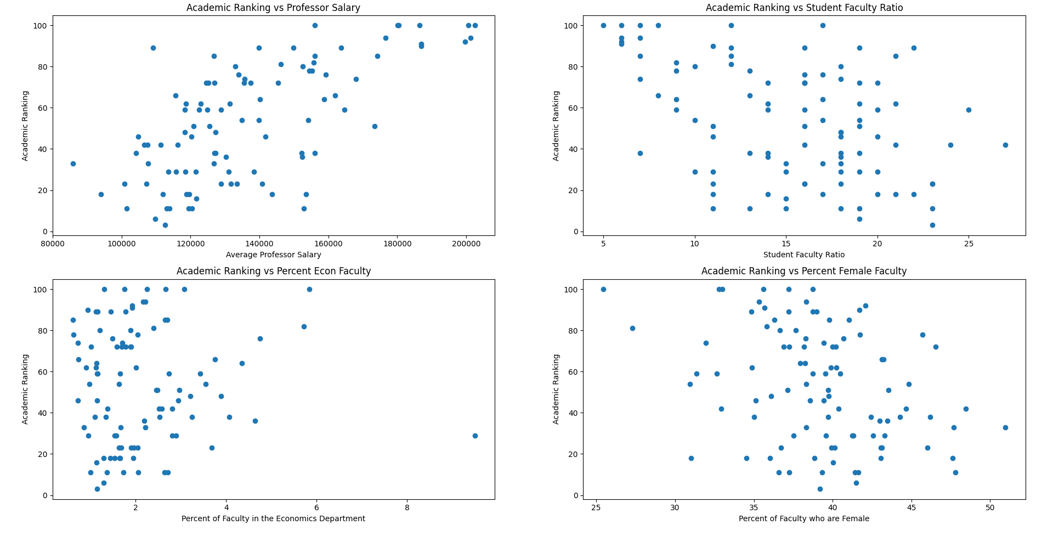

The above 4-quadrent chart shows the visual relationship between the dependent variable on the y-axis (academic ranking) and the explanatory variables plotted separately on each of the x-axis. The strongest relationship shown in the scatter diagrams is between average professor salary and academic rankings. We can see a general trend that as faculty pay increases, so does academic rankings. The variables student faculty ratio and percent female faculty show a negative, although less strong, relationships with academic ranking when compared to salary. Percent economics faculty shows no apparent relationship with academic rankings. These findings are quantified in the correlation matrix below. Visual inspection proves true, a positive correlation of 0.66 exists between salary and ranking. A negative correlation of -0.44 exists between student faculty ratio and ranking. Similarly, a negative correlation of -0.34 is recorded between percent female faculty and academic ranking. Lastly, the weak relationship between percent economics faculty and academic ranking is recorded with a correlation of 0.024.

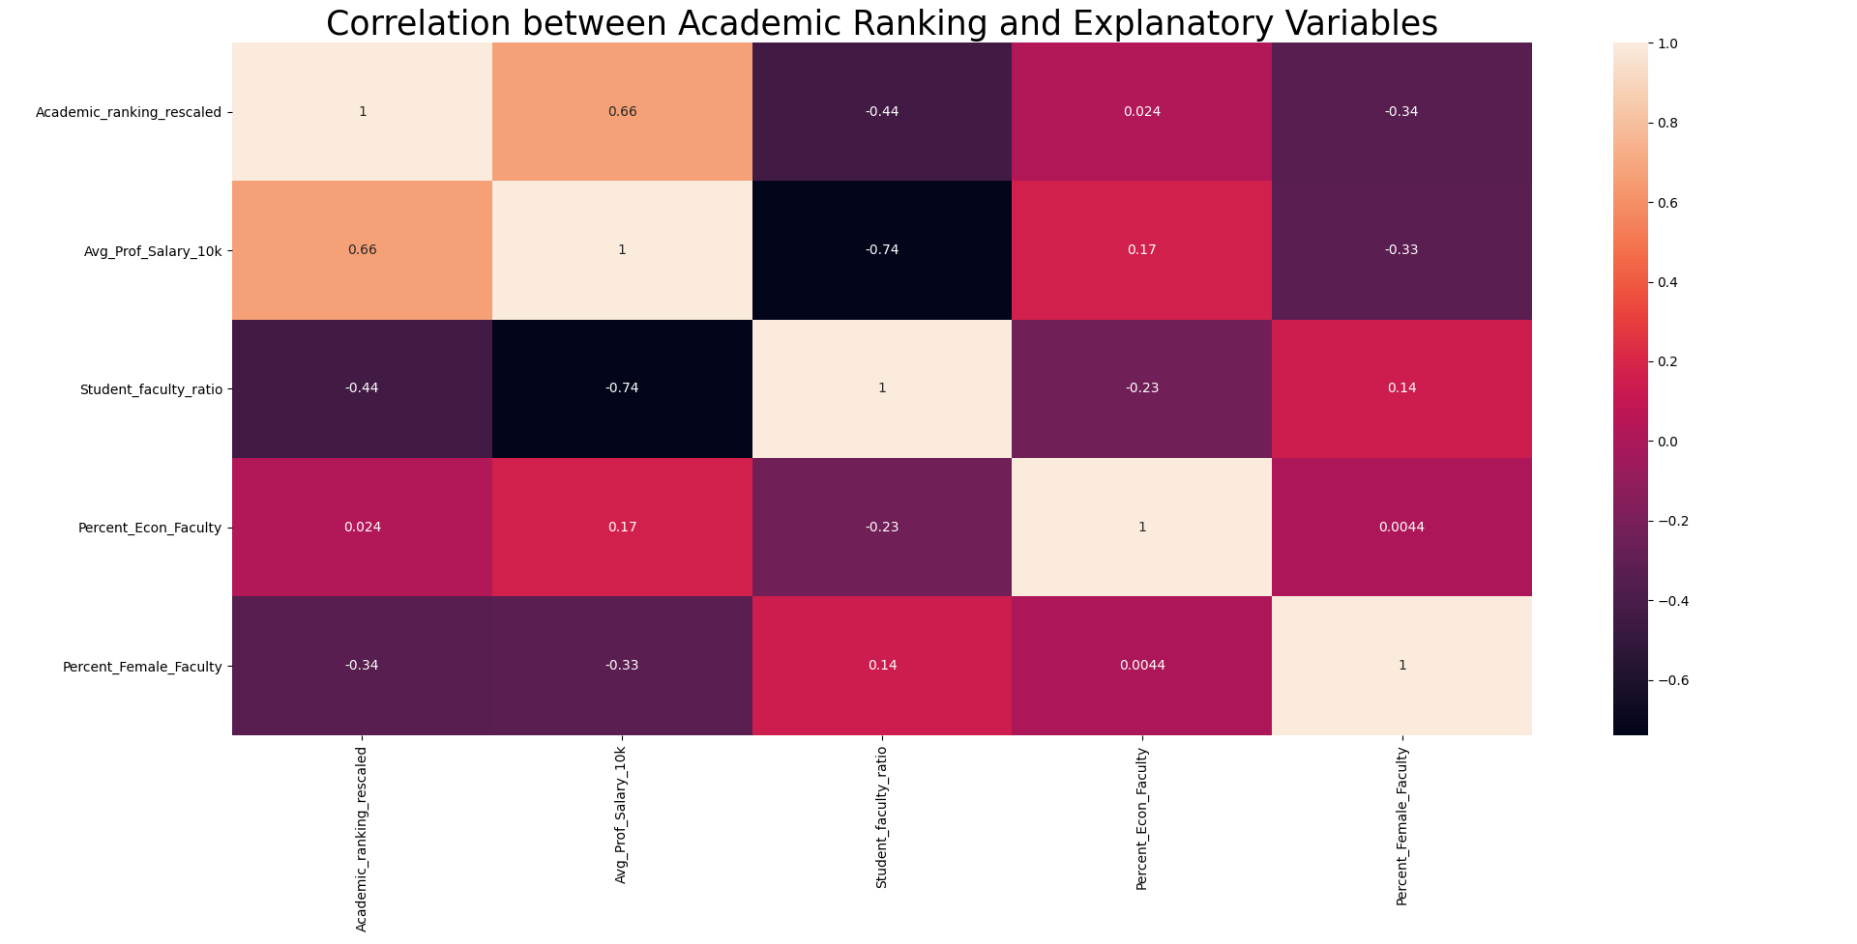

Regression Results:

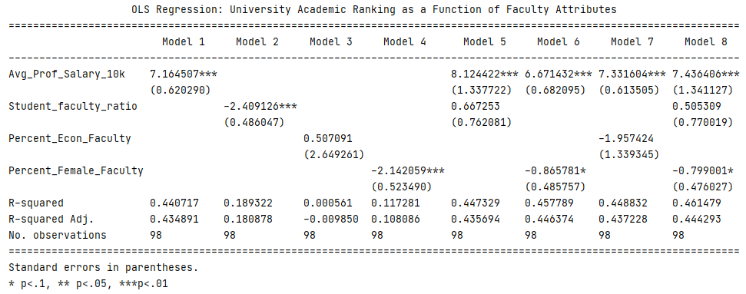

In the regression results above, the average professor salary data has been standardized to represent units of $10,000 (Avg_Prof_Salary_10k), making the resulting regression coefficients on salary easier to interpret. Standard errors (in parentheses) are heteroskedastic robust. The first four models in the regression show the stand-alone impact of each explanatory variable on academic ranking. Like the correlation results, we can see the direction relationship between each one of the explanatory variables and ranking. Within the stand-alone results, we can also see each one of the variables is statistically significant at the 99% significance level, except for percent economics faculty, where the relationship is statistically insignificant and weak. The first model indicates that if average professor salary is increased by $10,000, then a university can expect to increase by about 7.2 academic ranking units. The regression coefficient in model two indicates that if the student faculty ratio increases by one (more students, less faculty), then the academic ranking of a university can be expected to fall by about 2.4 units. Regarding models 3 and 4, a one percent increase in the percent economics faculty at a university can expected to increase academic ranking by about half a unit (although statistically insignificant), and a one percent increase in percent female faculty can expected to decrease academic ranking by 2.1 units. The most surprising result is the direction of the coefficient in model four. The result could be interpreted in a few ways. At a surface level, it appears that having a larger percentage of female faculty results in less impressive academic rankings. However, given that innate ability is likely evenly distributed among male and female faculty, the data likely reveal a bias at elite academic institutions towards hiring male faculty.

Models 5-8 add control variables to the primary x variable, average professor salary. Model 5 adds student faculty ratio as a control to average professor salary. Two conclusions result. First, the standard error of salary more than doubles when moving from model 1 to model 5 while still retaining 99% statistical significance. Second, the coefficient on student faculty ratio reverses direction between model 2 and model 5. The net effect suggests a high degree of multicollinearity between average salary and student faculty ratio. It seems the two variables largely measure the same thing, that being university financial resources. When referring to the correlation matrix, we can see a -0.74 correlation between the explanatory variables. The direction of the correlation is the opposite of what one might expect. Consider a university administration with a fixed budget for faculty resources. Traditionally, the administration would face a trade off between hiring more experienced and acclaimed faculty (higher salary) versus more absolute amounts of faculty (lower student faculty ratio). This traditional budget constraint relationship should theoretically show a positive correlation between average salary and student to faculty ratio. As salaries increase, student to faculty ratio should also be expected increase. However, the correlation data shows the opposite. As faculty salaries at universities increase, student faculty ratios actually decrease—indicating that as salaries increase so does the amount of faculty relative to the size of an institution. All of this points to a concentration resources in the academic realm: wealthier universities hire both the most expensive professors and higher more of them on a per student basis! Even with the multicollinearity observed between average salary and student faculty ratio—with both variables likely underpinned by university wealth—it is important to leave both variables in the model to control for the separated university “wealth” effects.

Model 6 shows a more muted effect of percent female faculty on academic ranking when controlling for average salary. As we move from model 4 to model 6, we can see the coefficient on percent female faculty loses some statistical significance but likely shows a more unbiased strength of relationship between percent female faculty and academic ranking when controlling for average salary. Model 7 still shows no statistically significant relationship between percent economics faculty and academic ranking, even when controlling for average salary. This makes some intuitive sense because a university can specialize in any subject matter and earn high academic ranking. Having a larger percentage of faculty devoted to economics or business subjects (or any subject matter) should not theoretically earn it a high ranking. Rather, it is the quality of study, not the concentration of study in any subject, that should drive ranking.

Model 8 shows the strongest theoretically sound and statistically significant result. Percent economics faculty has been removed as it shows limited explanatory power of academic ranking in the scatter plot, the correlation matrix and prior regression models. Two of the remaining three variables hold statistical significance at the 99% confidence and 90% confidence levels. The adjusted R-squared in model 8 is also one of the highest among previously discussed models, settling at 0.44. Further, the F-statistic, testing the joint significance of all three variables, is 39.68. This F-stat indicates that we can reject the null hypothesis that all three variables jointly have no effect on academic ranking by a wide margin (critical value 3.78 at the 1% alpha level). The student to faculty ratio loses statistical significance due to the previously discussed multicollinearity observed with average salary. Model 8 can, I this author’s option, be separated into a “university wealth” effect, equal to the sum of the beta coefficients on the salary and the student faculty ratio; and a percent female faculty effect—to explain academic rankings. Practically, the most useful result is that a $10,000 increase in average professor salary should increase a university’s ranking by about 7.4 ranking spots, or about one third of one standard deviation in the university raking hierarchy. In terms of policy recommendations, university administrations should focus on building their endowments to facilitate the ability to pay the highest earning professors, and more of them, with the end goal of increasing or retaining university ranking among peer universities. University administrators should also be cognizant of the bias towards hiring male faculty members at top notch schools when making faculty hiring decisions.